Computer Networks Lab 07
Name: Hafsa Salman
Roll no. 22K-5161

Task no. 01
//Code:
#include "ns3/core-module.h"
#include "ns3/network-module.h"
#include "ns3/internet-module.h"
#include "ns3/point-to-point-module.h"
#include "ns3/applications-module.h"
#include <fstream>

using namespace ns3;

NS_LOG_COMPONENT_DEFINE ("CongestionWindowExample");

std::ofstream cwndStream;

static void
CwndTracer (uint32_t oldCwnd, uint32_t newCwnd)
{
double time = Simulator::Now ().GetSeconds ();
cwndStream << time << " " << newCwnd << std::endl;
}

int
main (int argc, char *argv[])
{
CommandLine cmd;
cmd.Parse (argc, argv);

cwndStream.open ("cwnd.plt");

NodeContainer nodes;
nodes.Create (2);

PointToPointHelper pointToPoint;
pointToPoint.SetDeviceAttribute ("DataRate", StringValue ("5Mbps"));
pointToPoint.SetChannelAttribute ("Delay", StringValue ("2ms"));

NetDeviceContainer devices = pointToPoint.Install (nodes);

InternetStackHelper stack;
stack.Install (nodes);

Ipv4AddressHelper address;
address.SetBase ("10.1.1.0", "255.255.255.0");

Ipv4InterfaceContainer interfaces = address.Assign (devices);

uint16_t sinkPort = 8080;
Address sinkAddress (InetSocketAddress (interfaces.GetAddress (1), sinkPort));
PacketSinkHelper packetSinkHelper ("ns3::TcpSocketFactory", sinkAddress);
ApplicationContainer sinkApp = packetSinkHelper.Install (nodes.Get (1));
sinkApp.Start (Seconds (0.0));
sinkApp.Stop (Seconds (20.0));

BulkSendHelper source ("ns3::TcpSocketFactory", sinkAddress);
source.SetAttribute ("MaxBytes", UintegerValue (0));
ApplicationContainer sourceApp = source.Install (nodes.Get (0));
sourceApp.Start (Seconds (1.0));
sourceApp.Stop (Seconds (20.0));

Simulator::Schedule (Seconds (1.1), [&sourceApp]() {
Ptr<BulkSendApplication> app = DynamicCast<BulkSendApplication> (sourceApp.Get (0));
Ptr<Socket> sock = app->GetSocket ();
if (sock)
{
sock->TraceConnectWithoutContext ("CongestionWindow", MakeCallback (&CwndTracer));
}
else
{
std::cout << "Socket is NULL!" << std::endl;
}
});

Simulator::Run ();
Simulator::Destroy ();

cwndStream.close ();

return 0;
}

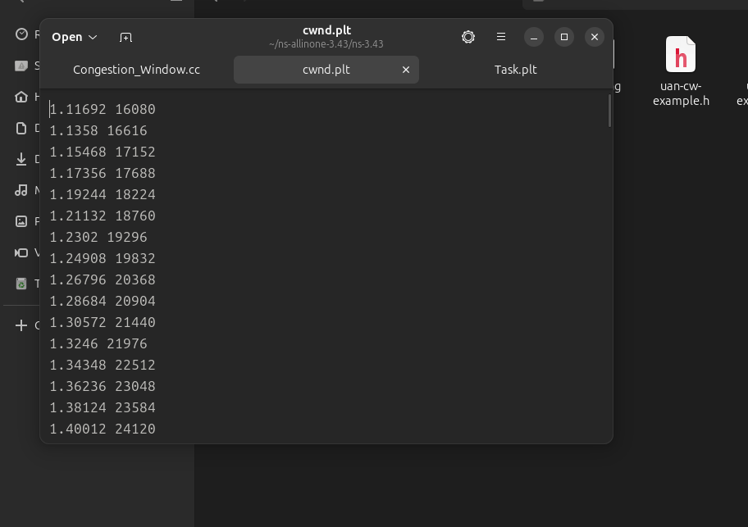
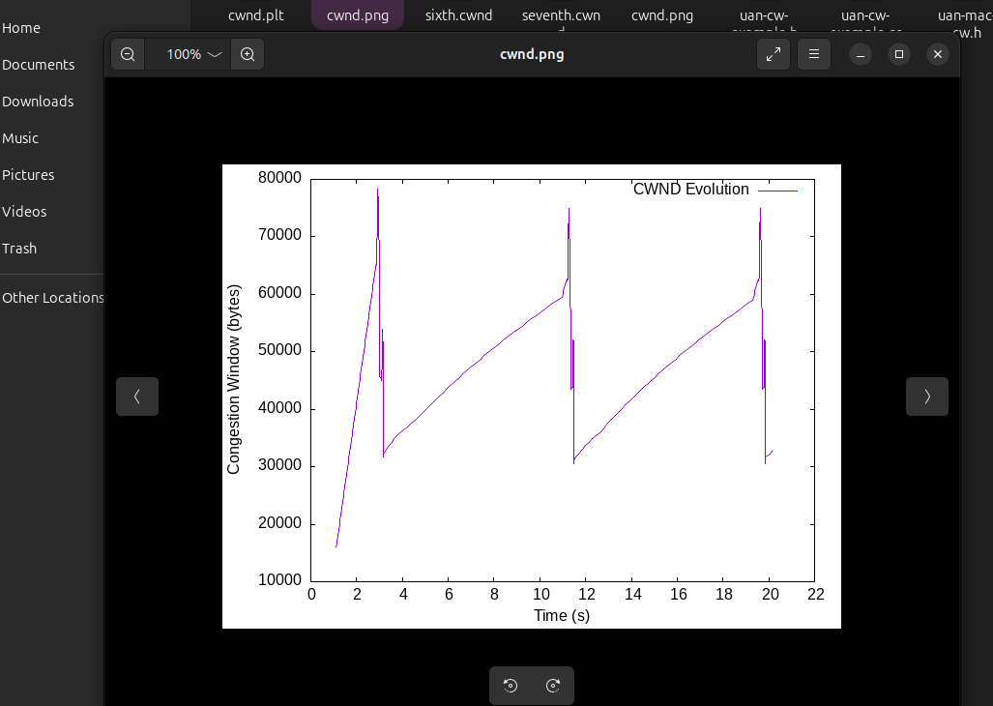

Task no. 02
//Code:
#include "ns3/core-module.h"
#include "ns3/network-module.h"
#include "ns3/internet-module.h"
#include "ns3/point-to-point-module.h"
#include "ns3/applications-module.h"
#include "ns3/flow-monitor-module.h"

using namespace ns3;

NS_LOG_COMPONENT_DEFINE("BandwidthAnalysis");

void RunSimulation(double bandwidthMbps)
{
NS_LOG_INFO("Running simulation with bandwidth: " << bandwidthMbps << " Mbps");

NodeContainer nodes;
nodes.Create(2);

std::ostringstream bandwidthStr;
bandwidthStr << static_cast<uint32_t>(bandwidthMbps) << "Mbps";

PointToPointHelper pointToPoint;
pointToPoint.SetDeviceAttribute("DataRate", StringValue(bandwidthStr.str()));
pointToPoint.SetChannelAttribute("Delay", StringValue("2ms"));

NetDeviceContainer devices;
devices = pointToPoint.Install(nodes);

InternetStackHelper stack;
stack.Install(nodes);

Ipv4AddressHelper address;
address.SetBase("10.1.1.0", "255.255.255.0");

Ipv4InterfaceContainer interfaces = address.Assign(devices);

uint16_t port = 9;
OnOffHelper onoff("ns3::UdpSocketFactory",
InetSocketAddress(interfaces.GetAddress(1), port));
onoff.SetAttribute("DataRate", StringValue("50Mbps"));
onoff.SetAttribute("PacketSize", UintegerValue(1024));
onoff.SetAttribute("StartTime", TimeValue(Seconds(1.0)));
onoff.SetAttribute("StopTime", TimeValue(Seconds(10.0)));

ApplicationContainer app = onoff.Install(nodes.Get(0));

PacketSinkHelper sink("ns3::UdpSocketFactory",
InetSocketAddress(Ipv4Address::GetAny(), port));
ApplicationContainer sinkApp = sink.Install(nodes.Get(1));
sinkApp.Start(Seconds(0.0));
sinkApp.Stop(Seconds(11.0));

FlowMonitorHelper flowmon;
Ptr<FlowMonitor> monitor = flowmon.InstallAll();

Simulator::Stop(Seconds(11.0));
Simulator::Run();

monitor->CheckForLostPackets();
Ptr<Ipv4FlowClassifier> classifier =
DynamicCast<Ipv4FlowClassifier>(flowmon.GetClassifier());
std::map<FlowId, FlowMonitor::FlowStats> stats = monitor->GetFlowStats();

for (auto const &flow : stats)
{
Ipv4FlowClassifier::FiveTuple t = classifier->FindFlow(flow.first);
if (t.destinationPort == port)
{
double throughput = flow.second.rxBytes * 8.0 / (flow.second.timeLastRxPacket.GetSeconds() - flow.second.timeFirstTxPacket.GetSeconds()) / 1e6;
double packetLossRatio = (double)(flow.second.txPackets - flow.second.rxPackets) / flow.second.txPackets * 100;

std::cout << "Bandwidth: " << bandwidthMbps << " Mbps\n";
std::cout << "Throughput: " << throughput << " Mbps\n";
std::cout << "Packet Loss: " << packetLossRatio << " %\n";
std::cout << "-----------------------------\n";
}
}

Simulator::Destroy();
}

int main(int argc, char *argv[])
{
LogComponentEnable("BandwidthAnalysis", LOG_LEVEL_INFO);

std::vector<double> bandwidths = {1.0, 5.0, 10.0};
for (double bw : bandwidths)
{
RunSimulation(bw);
}

return 0;
}

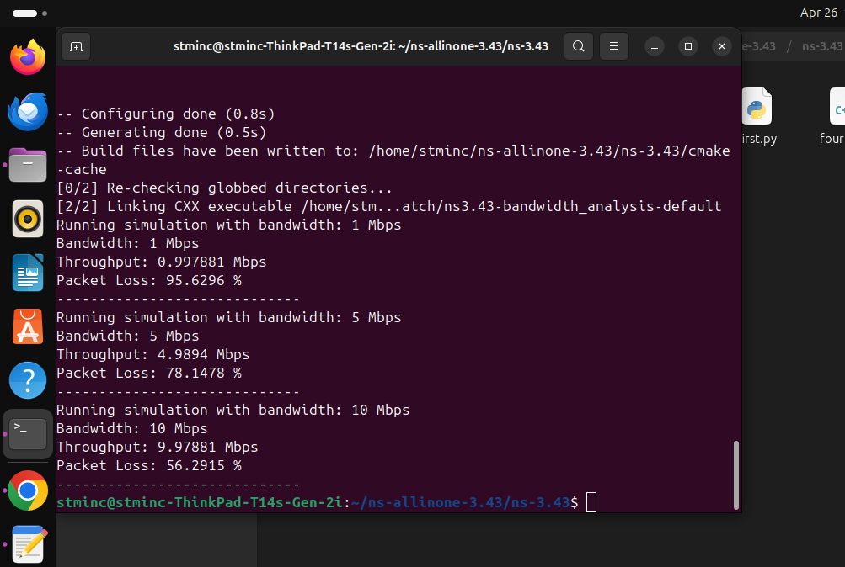

Task no. 03
//Code:
#include "ns3/core-module.h"
#include "ns3/network-module.h"
#include "ns3/internet-module.h"
#include "ns3/point-to-point-module.h"
#include "ns3/udp-client-server-helper.h"
#include "ns3/flow-monitor-module.h"

using namespace ns3;

NS_LOG_COMPONENT_DEFINE ("BufferManagementExample");

void RunSimulation(uint32_t queueSize, std::string queueSizeStr)
{
NodeContainer nodes;
nodes.Create (2);

PointToPointHelper p2p;
p2p.SetDeviceAttribute ("DataRate", StringValue ("2Mbps"));
p2p.SetChannelAttribute ("Delay", StringValue ("10ms"));
p2p.SetQueue("ns3::DropTailQueue", "MaxSize", StringValue(queueSizeStr));

NetDeviceContainer devices = p2p.Install (nodes);
InternetStackHelper stack;
stack.Install (nodes);

Ipv4AddressHelper address;
address.SetBase ("10.1.1.0", "255.255.255.0");
Ipv4InterfaceContainer interfaces = address.Assign (devices);

uint16_t port = 9;
UdpServerHelper server (port);
ApplicationContainer serverApp = server.Install (nodes.Get (1));
serverApp.Start (Seconds (1.0));
serverApp.Stop (Seconds (10.0));

UdpClientHelper client (interfaces.GetAddress (1), port);
client.SetAttribute ("MaxPackets", UintegerValue (1000000));
client.SetAttribute ("Interval", TimeValue (Seconds (0.00032))); // 5 Mbps
client.SetAttribute ("PacketSize", UintegerValue (1024));
ApplicationContainer clientApp = client.Install (nodes.Get (0));
clientApp.Start (Seconds (2.0));
clientApp.Stop (Seconds (10.0));

FlowMonitorHelper flowmon;
Ptr<FlowMonitor> monitor = flowmon.InstallAll();

Simulator::Stop (Seconds (11.0));
Simulator::Run ();

monitor->CheckForLostPackets();
Ptr<Ipv4FlowClassifier> classifier = DynamicCast<Ipv4FlowClassifier> (flowmon.GetClassifier());
std::map<FlowId, FlowMonitor::FlowStats> stats = monitor->GetFlowStats ();

for (auto iter : stats)
{
Ipv4FlowClassifier::FiveTuple t = classifier->FindFlow (iter.first);
if (t.destinationPort == port)
{
double packetLossRatio = (double)(iter.second.txPackets - iter.second.rxPackets) / iter.second.txPackets;
std::cout << "Queue Size: " << queueSize << " packets -- ";
std::cout << "Packet Loss Ratio: " << packetLossRatio * 100 << "%" << std::endl;
}
}

Simulator::Destroy ();
}

int main (int argc, char *argv[])
{
LogComponentEnable("BufferManagementExample", LOG_LEVEL_INFO);

std::cout << "Running simulations for different queue sizes...\n";

RunSimulation(5, "5p");
RunSimulation(10, "10p");
RunSimulation(50, "50p");

return 0;
}

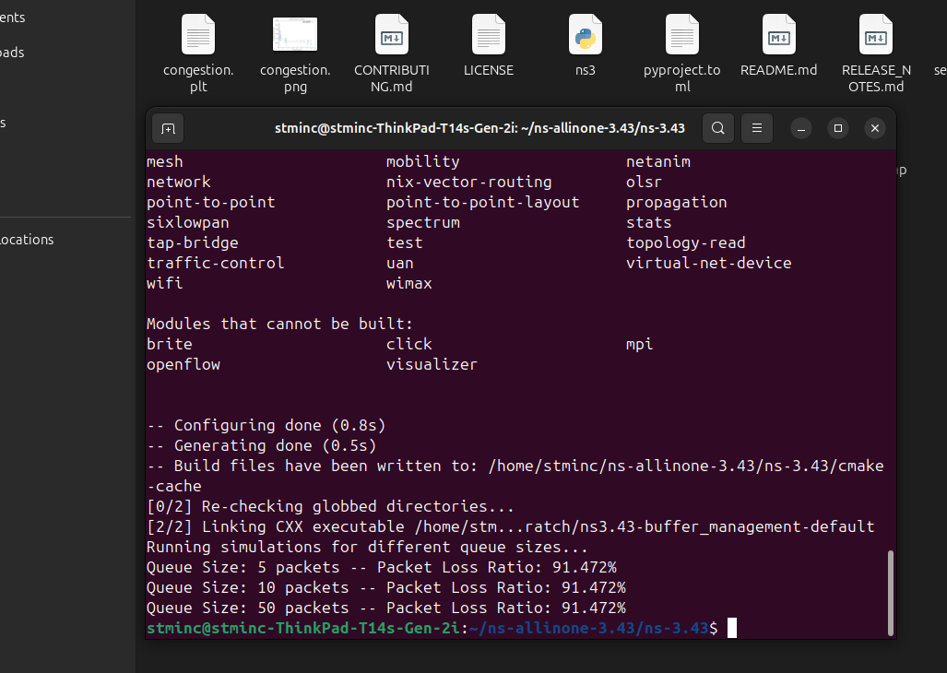

Task no. 04
//Code:
#include "ns3/core-module.h"
#include "ns3/network-module.h"
#include "ns3/internet-module.h"
#include "ns3/point-to-point-module.h"
#include "ns3/udp-client-server-helper.h"
#include "ns3/flow-monitor-module.h"

using namespace ns3;

NS_LOG_COMPONENT_DEFINE ("BottleneckAnalysis");

int main (int argc, char *argv[])
{
double offeredLoadMbps = 2.0;

CommandLine cmd;
cmd.AddValue ("offeredLoad", "Offered load in Mbps per sender", offeredLoadMbps);
cmd.Parse (argc, argv);

NodeContainer senders;
senders.Create (4);

NodeContainer routers;
routers.Create (2);

NodeContainer receivers;
receivers.Create (4);

InternetStackHelper stack;
stack.InstallAll();

PointToPointHelper p2pSenderRouter;
p2pSenderRouter.SetDeviceAttribute ("DataRate", StringValue ("10Mbps"));
p2pSenderRouter.SetChannelAttribute ("Delay", StringValue ("2ms"));

PointToPointHelper p2pRouterRouter;
p2pRouterRouter.SetDeviceAttribute ("DataRate", StringValue ("1Mbps"));
p2pRouterRouter.SetChannelAttribute ("Delay", StringValue ("10ms"));

PointToPointHelper p2pRouterReceiver;
p2pRouterReceiver.SetDeviceAttribute ("DataRate", StringValue ("10Mbps"));
p2pRouterReceiver.SetChannelAttribute ("Delay", StringValue ("2ms"));

NetDeviceContainer senderDevices[4];
for (int i = 0; i < 4; ++i)
{
senderDevices[i] = p2pSenderRouter.Install (senders.Get(i), routers.Get(0));
}

NetDeviceContainer routerDevices;
routerDevices = p2pRouterRouter.Install (routers);

NetDeviceContainer receiverDevices[4];
for (int i = 0; i < 4; ++i)
{
receiverDevices[i] = p2pRouterReceiver.Install (routers.Get(1), receivers.Get(i));
}

Ipv4AddressHelper address;
Ipv4InterfaceContainer senderInterfaces[4];
for (int i = 0; i < 4; ++i)
{
std::ostringstream subnet;
subnet << "10.1." << i+1 << ".0";
address.SetBase (subnet.str().c_str(), "255.255.255.0");
senderInterfaces[i] = address.Assign (senderDevices[i]);
}

address.SetBase ("10.1.5.0", "255.255.255.0");
Ipv4InterfaceContainer routerInterfaces = address.Assign (routerDevices);

Ipv4InterfaceContainer receiverInterfaces[4];
for (int i = 0; i < 4; ++i)
{
std::ostringstream subnet;
subnet << "10.1." << i+6 << ".0";
address.SetBase (subnet.str().c_str(), "255.255.255.0");
receiverInterfaces[i] = address.Assign (receiverDevices[i]);
}

uint16_t port = 5000;
ApplicationContainer serverApps;
ApplicationContainer clientApps;

for (int i = 0; i < 4; ++i)
{
UdpServerHelper server (port + i);
serverApps.Add (server.Install (receivers.Get(i)));

UdpClientHelper client (receiverInterfaces[i].GetAddress(1), port + i);
client.SetAttribute ("MaxPackets", UintegerValue (1000000));
client.SetAttribute ("Interval", TimeValue (Seconds (1.0 / (offeredLoadMbps * 125.0))));
client.SetAttribute ("PacketSize", UintegerValue (1024));

clientApps.Add (client.Install (senders.Get(i)));
}

serverApps.Start (Seconds (1.0));
serverApps.Stop (Seconds (10.0));

clientApps.Start (Seconds (1.0));
clientApps.Stop (Seconds (10.0));

Ipv4GlobalRoutingHelper::PopulateRoutingTables ();

FlowMonitorHelper flowmon;
Ptr<FlowMonitor> monitor = flowmon.InstallAll();

Simulator::Stop (Seconds (11.0));
Simulator::Run ();

monitor->CheckForLostPackets();
Ptr<Ipv4FlowClassifier> classifier = DynamicCast<Ipv4FlowClassifier> (flowmon.GetClassifier());
std::map<FlowId, FlowMonitor::FlowStats> stats = monitor->GetFlowStats ();

std::cout << "\n--- Throughput per flow (offered load per sender: " << offeredLoadMbps << " Mbps) ---\n";
for (auto iter : stats)
{
Ipv4FlowClassifier::FiveTuple t = classifier->FindFlow (iter.first);
if (t.destinationPort >= port && t.destinationPort <= port + 3)
{
double throughput = iter.second.rxBytes * 8.0 / (iter.second.timeLastRxPacket.GetSeconds() - iter.second.timeFirstTxPacket.GetSeconds()) / 1e6;
std::cout << "Flow from " << t.sourceAddress << " to " << t.destinationAddress
<< " : Throughput = " << throughput << " Mbps" << std::endl;
}
}

Simulator::Destroy ();

return 0;
}
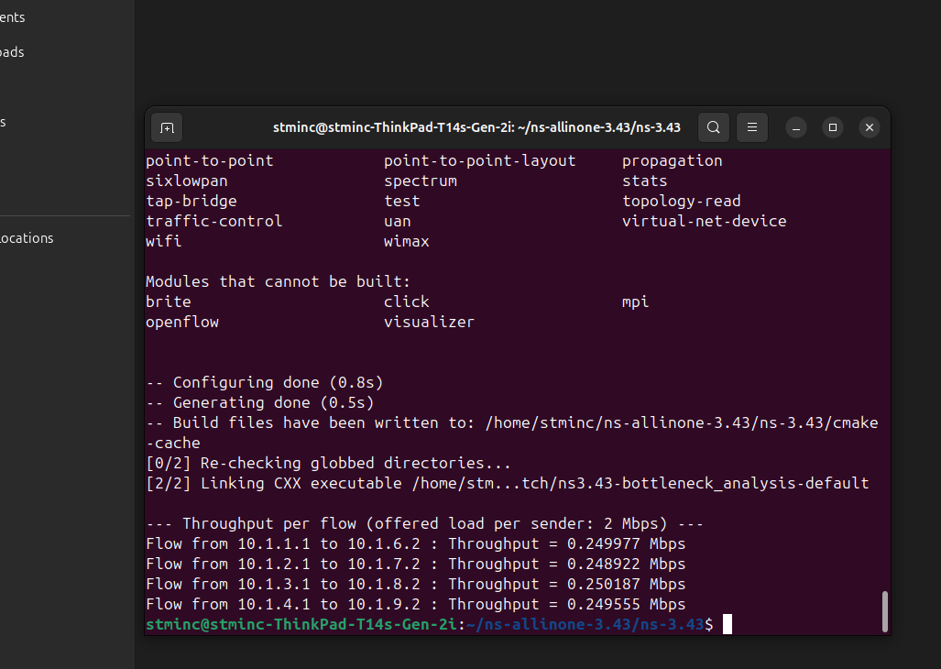

Task no. 05
//Code:
#include "ns3/core-module.h"
#include "ns3/network-module.h"
#include "ns3/internet-module.h"
#include "ns3/wifi-module.h"
#include "ns3/mobility-module.h"
#include "ns3/applications-module.h"
#include "ns3/flow-monitor-module.h"

using namespace ns3;

NS_LOG_COMPONENT_DEFINE("WifiDataLossExample");

int main(int argc, char *argv[])
{
LogComponentEnable("UdpClient", LOG_LEVEL_INFO);
LogComponentEnable("UdpServer", LOG_LEVEL_INFO);

NodeContainer wifiStaNodes;
wifiStaNodes.Create(3);
NodeContainer wifiApNode;
wifiApNode.Create(1);

YansWifiChannelHelper channel = YansWifiChannelHelper::Default();
YansWifiPhyHelper phy;
phy.SetChannel(channel.Create());

WifiHelper wifi;
wifi.SetStandard(WIFI_STANDARD_80211g);
wifi.SetRemoteStationManager("ns3::MinstrelWifiManager");

WifiMacHelper mac;
Ssid ssid = Ssid("wifi-data-loss");

mac.SetType("ns3::StaWifiMac",
"Ssid", SsidValue(ssid),
"ActiveProbing", BooleanValue(false));
NetDeviceContainer staDevices;
staDevices = wifi.Install(phy, mac, wifiStaNodes);

mac.SetType("ns3::ApWifiMac",
"Ssid", SsidValue(ssid));
NetDeviceContainer apDevice;
apDevice = wifi.Install(phy, mac, wifiApNode);

MobilityHelper mobility;
Ptr<ListPositionAllocator> positionAlloc = CreateObject<ListPositionAllocator>();

positionAlloc->Add(Vector(0.0, 0.0, 0.0));
positionAlloc->Add(Vector(10.0, 0.0, 0.0));
positionAlloc->Add(Vector(50.0, 0.0, 0.0));
positionAlloc->Add(Vector(100.0, 0.0, 0.0));
mobility.SetPositionAllocator(positionAlloc);
mobility.SetMobilityModel("ns3::ConstantPositionMobilityModel");

mobility.Install(wifiApNode);
mobility.Install(wifiStaNodes);

InternetStackHelper stack;
stack.Install(wifiApNode);
stack.Install(wifiStaNodes);

Ipv4AddressHelper address;
address.SetBase("192.168.1.0", "255.255.255.0");

Ipv4InterfaceContainer staInterfaces;
staInterfaces = address.Assign(staDevices);
Ipv4InterfaceContainer apInterface;
apInterface = address.Assign(apDevice);

uint16_t port = 9;
UdpServerHelper server(port);

ApplicationContainer serverApps = server.Install(wifiStaNodes);
serverApps.Start(Seconds(1.0));
serverApps.Stop(Seconds(10.0));

UdpClientHelper client(staInterfaces.GetAddress(0), port);
client.SetAttribute("MaxPackets", UintegerValue(320));
client.SetAttribute("Interval", TimeValue(MilliSeconds(50)));
client.SetAttribute("PacketSize", UintegerValue(1024));

ApplicationContainer clientApp = client.Install(wifiApNode.Get(0));
clientApp.Start(Seconds(2.0));
clientApp.Stop(Seconds(10.0));

UdpClientHelper interferer1(staInterfaces.GetAddress(1), port);
interferer1.SetAttribute("MaxPackets", UintegerValue(320));
interferer1.SetAttribute("Interval", TimeValue(MilliSeconds(20)));
interferer1.SetAttribute("PacketSize", UintegerValue(512));

ApplicationContainer interfererApps1 = interferer1.Install(wifiStaNodes.Get(1));
interfererApps1.Start(Seconds(3.0));
interfererApps1.Stop(Seconds(10.0));

UdpClientHelper interferer2(staInterfaces.GetAddress(2), port);
interferer2.SetAttribute("MaxPackets", UintegerValue(320));
interferer2.SetAttribute("Interval", TimeValue(MilliSeconds(25)));
interferer2.SetAttribute("PacketSize", UintegerValue(512));

ApplicationContainer interfererApps2 = interferer2.Install(wifiStaNodes.Get(2));
interfererApps2.Start(Seconds(3.5));
interfererApps2.Stop(Seconds(10.0));

FlowMonitorHelper flowmon;
Ptr<FlowMonitor> monitor = flowmon.InstallAll();

Simulator::Stop(Seconds(11.0));
Simulator::Run();

monitor->CheckForLostPackets();
Ptr<Ipv4FlowClassifier> classifier = DynamicCast<Ipv4FlowClassifier>(flowmon.GetClassifier());
std::map<FlowId, FlowMonitor::FlowStats> stats = monitor->GetFlowStats();

for (auto iter = stats.begin(); iter != stats.end(); ++iter)
{
Ipv4FlowClassifier::FiveTuple t = classifier->FindFlow(iter->first);
std::cout << "Flow ID: " << iter->first << " (" << t.sourceAddress << " -> " << t.destinationAddress << ")\n";
std::cout << " Tx Packets = " << iter->second.txPackets << "\n";
std::cout << " Rx Packets = " << iter->second.rxPackets << "\n";
std::cout << " Packet Loss = " << iter->second.txPackets - iter->second.rxPackets << "\n";
std::cout << " Throughput = " << (iter->second.rxBytes * 8.0 / (iter->second.timeLastRxPacket.GetSeconds() - iter->second.timeFirstTxPacket.GetSeconds())) / 1024 / 1024 << " Mbps\n";
}

Simulator::Destroy();
return 0;
}
